WriteUp

Q1a.

As, we have to create 3 threads. So, I created three threads with having countA for thread 1, countB for thread 2, count C for thread 3.

I have created two file q1check and q1histoandthread

File q1check:

In, this we checking is thread2 invokes thread 1 and thread 3. Similar goes for other like this:

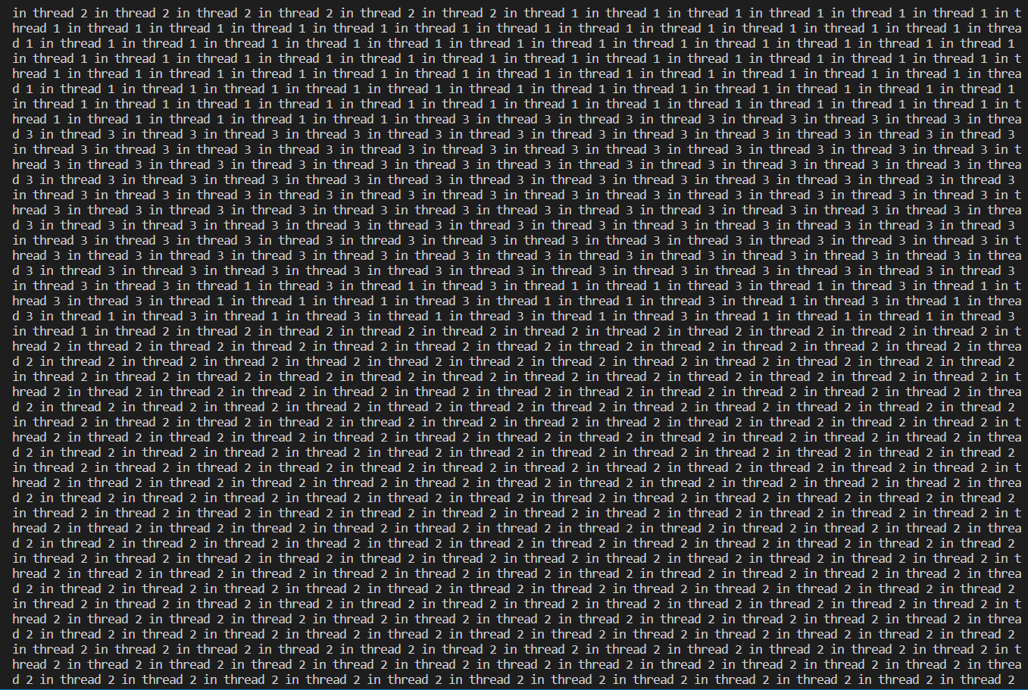

Here first thread 2 is compiling then thread 1 invokes, then thread 3 etc.

We have used pthread_create to invoke the function.

For getting the above output we have used pthread_setschedparam to set which thread1, which policy and priority we will use

thread 1 is set with SCHED_OTHER

thread 2 is set with SCHED_RR

thread 3 is set with SCHED_FIFO

with thread 1 having nice priority 0 and rest have default priority.

For q1histoandthread:

We have used pthread_create to invoke the function.

For getting the above output we have used pthread_setschedparam to set which thread1, which policy and priority we will use

thread 1 is set with SCHED_OTHER

thread 2 is set with SCHED_RR

thread 3 is set with SCHED_FIFO

with thread 1 having nice priority 0 and rest have default priority.

In every function of countA, countB and countC we have defined struct timeval start, end followed by gettimeofday for start function to start and after counting no’s, again gettimeofday for end to invoke to calculate how much it has taken to finish the function.

Lastly, we have defined hist array of size 3 for drawing histogram. After, every thread is finished we store that time values to draw the histogram.

Thread run time and variations + histogram

We are given 3 threads, thread 1, thread 2 and thread 3. We, have to find time variation of due the different process/thread scheduling policies and priorities.

Here’s what we get

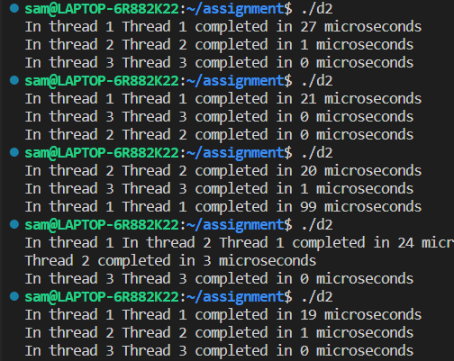

Above we can different variation of thread times due to different-different thread. In first output, first thread 1 is involved and completed then thread 2 is invoked and thread 3. In, second output thread 2 is invoked first then thread 2 and so goes on.

Histograms

